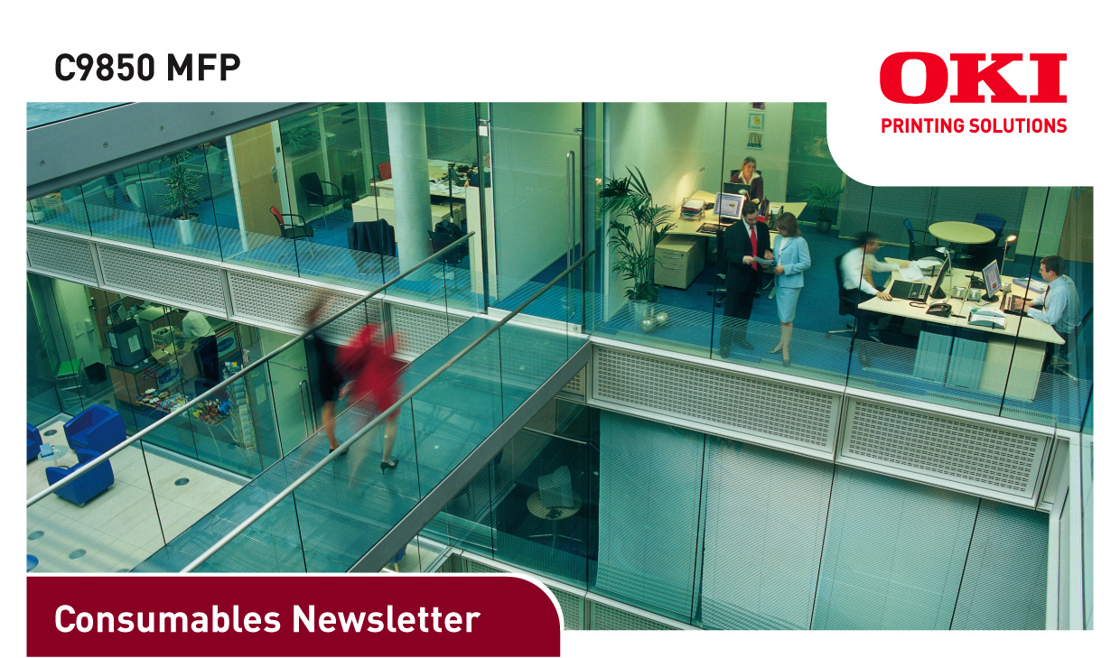

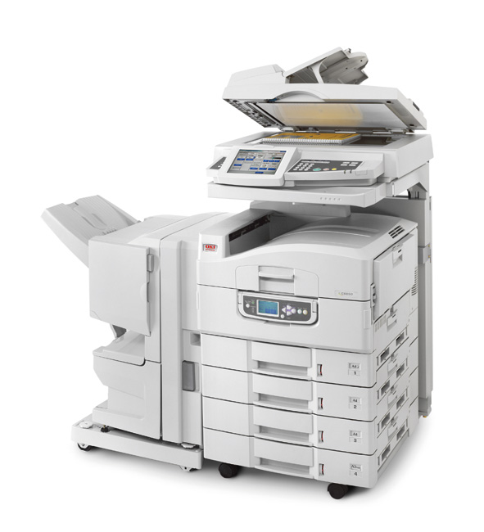

DATE: September 2008
ISSUED BY: Jane Mannering (jane.mannering@okieurope.com)
SUBJECT: C9850 MFP Consumables

C9850 MFP consumables update
• New C9850 MFP providing high performance business printing
• 36ppm colour and 40ppm mono at A4 to handle high volume printing comfortably
• Fast, single pass double-sided printing as standard & optional booklet finishing available
• Colour management from EFI FieryTM system 8e, for impressive colour print quality
• Unique embedded EFI ‘SendMe’ document distribution and management solution (DMS)
• 21cm colour touchscreen panel display keeps every operation clear, simple and easy to use
• ‘Ask Oki’ provides instant access to on-line advice and technical support

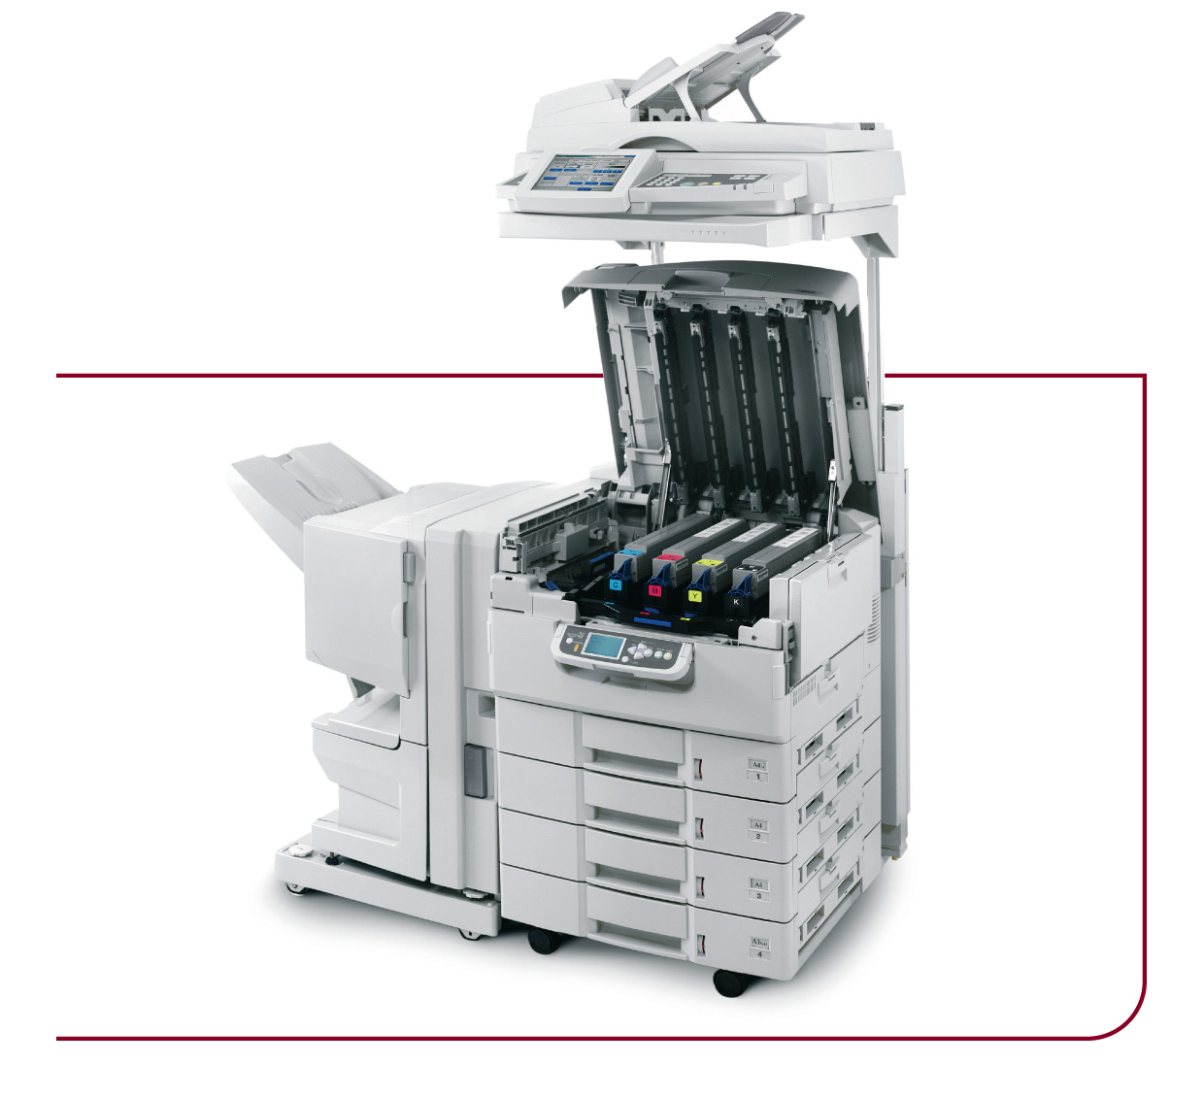

C9850 MFP
Product | Toner Black | Toner Cyan | Toner Magenta | Toner Yellow | Toner Rainbow Kit
Available From | September 2008 | September 2008 | September 2008 | September 2008 | September 2008
Order Code | 42918916 | 42918915 | 42918914 | 42918913 | 43112702
EAN Code | 5031713026846 | 5031713026839 | 5031713026822 | 5031713026815 | 5031713028895
Pallet Quantity | 144 | 144 | 144 | 144 | 50
Minimum Order Quantity | 6 | 6 | 6 | 6 | 1
Yield | 15, 000 pages A4  at 5% density | 15,000 pages A4  at 5% density | 15,000 pages A4  at 5% density | 15,000 pages A4  at 5% density | 15,000 pages A4 at  5% density per colour
New or Existing Product | existing | existing | existing | existing | existing
Compatible With | C9600/C9650/C9800/  C9850/C9800 MFP | C9600/C9650/C9800/  C9850/C9800 MFP | C9600/C9650/C9800/  C9850/C9800 MFP | C9600/C9650/C9800/  C9850/C9800 MFP | C9600/C9650/C9800/  C9850/C9800 MFP
Weight Kg  (box & consumable) | 0.880 | 0.880 | 0.880 | 0.880 | 3.300
Dimensions in mm of packaging w x d x h | 484 x 102 x 117 | 484 x 102 x 117 | 484 x 102 x 117 | 484 x 102 x 117 | 483 x 279 x 141

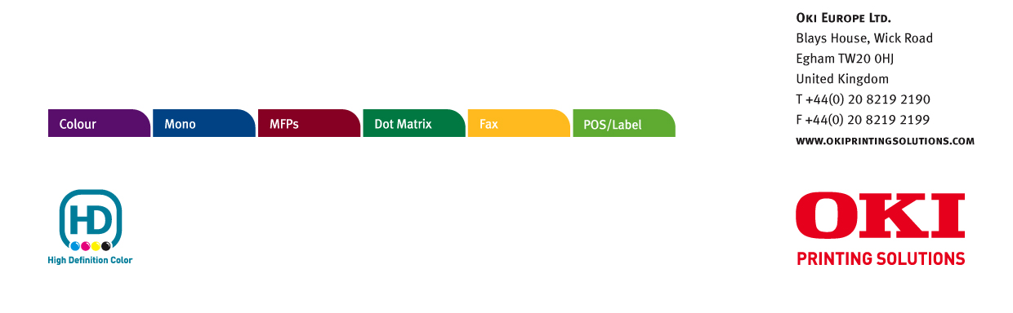
© 2008 Oki Europe Ltd. Oki Printing Solutions is the trading name of Oki Europe Ltd. Version 1.0 9.2008.

C9850 MFP
Product | Image Drum Black | Image Drum Cyan | Image Drum Magenta | Image Drum Yellow
Available From | September 2008 | September 2008 | September 2008 | September 2008
Order Code | 42918108 | 42918107 | 42918106 | 42918105
EAN Code | 5031713026570 | 5031713026563 | 5031713026556 | 5031713026549
Pallet Quantity | 32 | 32 | 32 | 32
Minimum Order Quantity | 4 | 4 | 4 | 4
Yield | 30,000 pages A4* | 30,000 pages A4* | 30,000 pages A4* | 30,000 pages A4*
New or Existing Product | existing | existing | existing | existing
Compatible With | C9600/C9650/C9800/  C9850/C9800 MFP | C9600/C9650/C9800/  C9850/C9800 MFP | C9600/C9650/C9800/  C9850/C9800 MFP | C9600/C9650/C9800/  C9850/C9800 MFP
Weight Kg  (box & consumable) | 1.000 | 1.000 | 1.000 | 1.000
Dimensions in mm of packaging w x d x h | 528 x 162 x 200 | 528 x 162 x 200 | 528 x 162 x 200 | 528 x 162 x 200

* Average A4 life based on a typical office environment

Product | Transfer Belt | Fuser Unit | Waste Toner System | Staples (box of 3 cartridges)
Available From | September 2008 | September 2008 | September 2008 | September 2008
Order Code | 42931603 | 42931703 | 42869403 | 42937603
EAN Code | 5031713026990 | 5031713026983 | 5031713027003 | 5031713027010
Pallet Quantity | 20 | 63 | 96 | n/a
Minimum Order Quantity | 1 | 1 | 1 | 1 box of 5,000 staples
Yield | 100,000 pages (A4 LEF)  at 3 pages per job | 100,000 pages (A4 LEF) | 30,000 pages | n/a
New or Existing Product | existing | existing | existing | existing
Compatible With | C9600/C9650/C9800/  C9850/C9800 MFP | C9600/C9650/C9800/  C9850/C9800 MFP | C9600/C9650/C9800/  C9850/C9800 MFP | C9600/C9650/C9800/  C9850/C9800 MFP
Weight Kg  (box & consumable) | 4.600 | 3.600 | 0.700 | 0.550
Dimensions in mm of packaging w x d x h | 489 x 459 x 199 | 517 x 217 x 141 | 575 x 160 x 105 | 163 x 64 x 42

OKI EUROPE LTD.
Blays House, Wick Road
Egham TW20 0HJ
United Kingdom
T +44(0) 20 8219 2190
F +44(0) 20 8219 2199
WWW.OKIPRINTINGSOLUTIONS.COM

