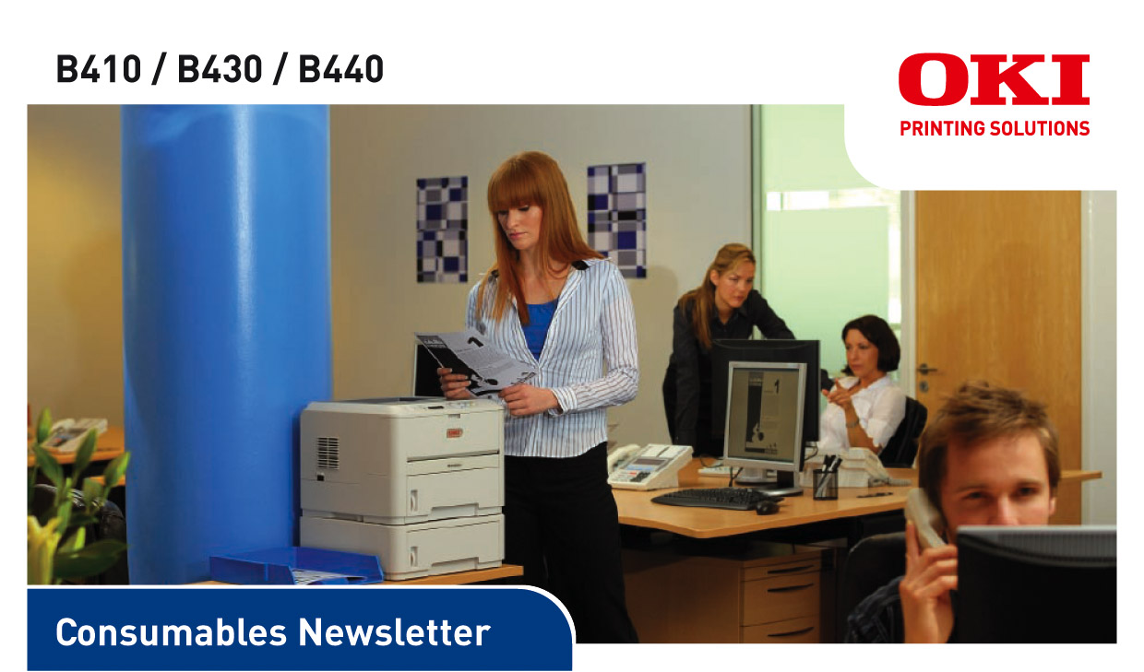
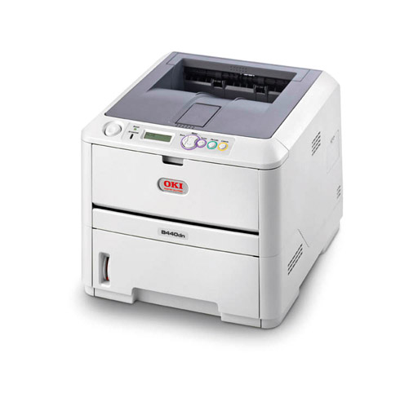
DATE: September 2008
ISSUED BY: Jane Mannering (jane.mannering@okieurope.com)
SUBJECT: B410, B430 and B440 Consumables

B410/B430/B440 consumables update
• Robust, simple design with ultra-reliable digital LED print technology
• Dependable performance with 28ppm print speed, with first page printing in just 5.5 seconds
• Automatic two-sided printing as standard
• Powerful productivity software to make life in the office easier than ever

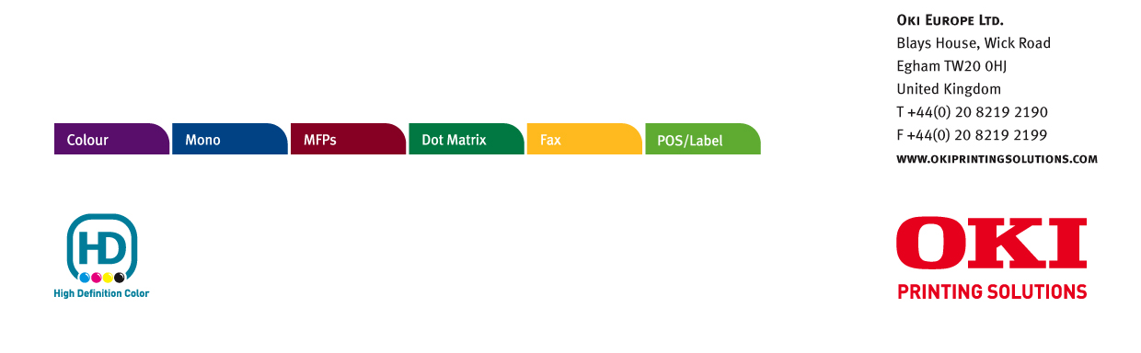

© 2008 Oki Europe Ltd. Oki Printing Solutions is the trading name of Oki Europe Ltd. Version 1.0 9.2008.

B410 / B430 / B440
Product | Toner Cartridge  (3.5k) | Toner Cartridge  (7k) | Toner Cartridge  (10k) | Image Drum
Available From | November 2008 | November 2008 | November 2008 | November 2008
Order Code | 43979102 | 43979202 | 43979207 | 43979002
EAN Code | 5031713042327 | 5031713042358 | 5031713042389 | 5031713034570
Pallet Quantity | 864 | 576 | 288 | 108
Minimum Order Quantity | 6 | 6 | 6 | 6
Yield | 3,500 pages A4* | 7,000 pages A4* | 10,000 pages A4* | 25,000 pages A4**  continuous print
New or Existing Product | new | new | new | new
Compatible With | B410/B430/B440 | B430/B440 | B440 | B410/B430/B440
Weight Kg  (box & consumable) | 0.185 | 0.420 | 0.440 | 1.300
Dimensions in mm of  packaging w x d x h | 262 x 47 x 46 | 262 x 57 x 71 | 262 x 113 x 79 | 289 x 122 x 82

* Yield compliant with ISO/IEC 19752 ** 20,000 pages A4 at 3 pages per job

OKI EUROPE LTD.
Blays House, Wick Road
Egham TW20 0HJ
United Kingdom
T +44(0) 20 8219 2190
F +44(0) 20 8219 2199
WWW.OKIPRINTINGSOLUTIONS.COM

